Application of Alien Residence Certificate (ARC)
For NCU Foreign Students
- Students who enter Taiwan with a visitor visa.
Step 1. Apply for a resident visa at the Taipei Bureau of Consular Affairs, Ministry of Foreign Affairs
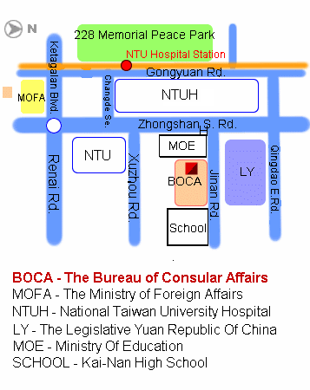
with the following documents in original & photocopy:
- Student ID Card
- Two photos (the size as ROC ID Card of Taiwan Residents)
- Passport
- Acceptance Letter
- Financial Statement of NT$500,000 within one month, which declares the account could be withdrew in Taiwan, with verification by Taipei Economic and Culture in foreign country.
- Scholarship Certificate
- Original Diploma & Transcript with verification by Taipei Economic and Culture in foreign country
- Proof of Enrollment (English)
- Receipt of tuition
- Health Certificate, if applicable.
- Fee: NT$3000
(NT$4400 of U.S citizens)
Add.: 4 Fl., 2-2 Chi-Nan Rd., Sec.1, Taipei Tel: (02)23432894, (02)2343-2885，(02) 2343-2895
Transportation: Taipei MRT – Xindian Line (Red) (Taipei Train Station => NTU Hospital Station)
Taipei Bureau of Consular Affairs, Ministry of Foreign Affairs =>http://www.boca.gov.tw/content.asp

Step 2. After about one week, get your passport from the Bureau of Consular Affairs along with your receipt.

Step 3. Go to the “National Immigration Agency Taoyuan County Service Center” for the application of your Alien Residence Certificate (ARC) with the following documents:
- Student ID Card 5. Passport
- Two photos (the size as ROC ID Card of Taiwan Residents) 6. Receipt of Tuition
- Staying in Dormitory Certificate or the letter to prove where you stay. 7. Fee NT$1000
- English Proof of Enrollment (Apply from Registry Office with NT$10)
Add.: No.106 Hsien-fu Road, Taoyuan City, Taoyuan County Tel: 03-3314830、03-3310409、03-3318243
Transportation: Taoyuan Bus 1
http://www.immigration.gov.tw/aspcode/index_ch_main.asp
- Students with a resident visa or Student ARC, please go through step 3 for ARC application.
- Remarks

1. Resident visa holders who are expected to live in Taiwan should apply for Alien Resident Certificate within 15 days after arriving in Taiwan.

2. An alien resident who wants to leave and return back to Taiwan should bring his/her passport, valid ARC with Re-entry Permit for passing the Immigration at the airport or at the harbor.

3. Students must always hold ARC with themselves during staying in Taiwan.

4. An applicant may authorize a third person to file his/her application.

5. The fee for renewal of an Alien Resident Certificate that has been damaged or list is NT$500.

6. The Photo Format of Applications
A thin half-length color photo with a glossy finish taken with a white background within the last six months that should be 4.5cm X 3.5cm with an image of the head that should not be shorter than 3.2cm or longer than 3.6cm from the top of the head to the chin, without wearing a hat or a pair of color glasses, with clear facial features not covered and identifiable, and should not be modified or composed. http://www.immigration.gov.tw/immig_eng/aspcode/showimmignews.asp?id=15
3.5cm
4.5cm
not smaller than 3.2cm
Not bigger than 3.6
cm
中央大學僑外生申請居留證流程
- 持停留簽證入境:
一、 至『台北外交部領事事務局』申請學生居留簽證。
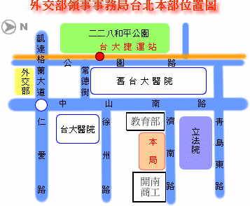
地址: 台北市濟南路一段2-2號4樓
電話: :(02)23432894, (02)2343-2885，(02) 2343-2895
交通：台北捷運：新店線（紅）
台北火車站＝＞台大醫院站
請帶: 1. 學生證
2. 二張２吋照片(身分證規格)
3. 護照
4. 入學許可證
5. 獎學金證明
6. 經駐外使館認證相當台幣50萬元以上之父母或法定代理人之財力證明，
且得於台灣支領。
7. 畢業證書、成績單(經駐外使館認證)
8. 英文在學證明
9. 繳費收據
10. 健康檢查合格證明
11. 費用NT$3000 (美國籍學生：NT$4400)
二、依指定日期（約一星期），帶著收據，領回護照。
三、至『內政部入出國及移民署桃園服務站』辦理居留證。
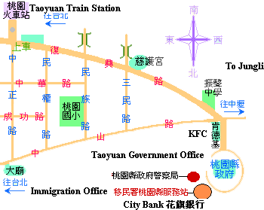
地址：桃園市縣府路106號
電話：03-3314830
交通：１路公車
請帶：1. 學生證
2. 二張２吋照片(身分正規格)
3. 護照
4. 英文在學證明書
5. 住宿證明或校外住址證明
6. 繳費單
7. 外籍生NT$1,000
- 持「學生居留簽證」入境或延長居留証，直接循第三項流程辦理。

備註:
- 持居留簽證者須於抵達台灣15日內申辦居留證ARC。
- 出入境期間務必於機場出示護照、註明重入境之外僑居留證。
- 學生務必隨身攜帶外僑居留證。
- 申請者得委託代理申請。
- 重新申辦損壞之外僑居留證費用500元。
- 申請來台證照，比照身分證之照片規格。

「各類入出國（境）許可申請案件所附照片規格」
最近６個月內所拍攝、直４．５公分且橫３．５公
分、脫帽、未戴有色眼鏡、五官清晰、不遮蓋、足資辨
識人貌、人像自頭頂至下顎之長度不得小於３．２公分
及超過３．６公分、白色背景之正面半身薄光面紙彩色
照片，且不得修改或使用合成照片。
http://www.immigration.gov.tw/aspcode/showann.asp?id=62

3.5公分
4.5公分
不得小於3.2公分
不得大於3.6公分

